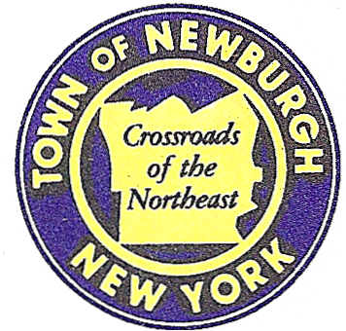

TOWN OF NEWBURGH
_______Crossroads of the Northeast __________________________
OLD TOWN HALL
308 GARDNERTOWN ROAD NEWBURGH, NEW YORK 12550

PLANNING BOARD
JOHN P. EWASUTYN, CHAIRMAN
TELEPHONE 845-564-7804
FAX 845-564-7802
E-MAIL: planningboard@townofnewburgh.org

PLANNING BOARD AGENDA

October 4th, 2018

*PLEASE NOTE: The Planning Board Meeting will start at 7:00 P.M. and all Applicants/Representatives
are to be present at that time. The Meeting will be held in the Meeting Room of Town Hall,
located at 1496 Route 300, Newburgh NY.*

- Gardnertown Commons (16-03) AMENDED ARB
Section 75, Block 1, Lot 21
Zone: R-3
Rep: JMC Planning Engineering /Mauri Architects
120 Bedford Road 73 Mansion St.
Armonk, N.Y. 10504 Poughkeepsie, NY 12601

- Bracken 17 Ventures LLC (18-15) TWO LOT SUBDIVISION
Fleetwood Drive
Section 87, Block 2, Lot 1.2
Zone: R-1
Rep: Vincent J. Doce Associates/Darren Doce
242 South Plank Rd.
Newburgh, NY 12550

- A Plus Auto And Truck, LLC (18-17) INITIAL APPEARANCE
12 Little Lane Road SITE PLAN
Section 53, Block 4, Lot 4.21
Zone: B
Rep: Engineering & Surveying Properties, PC
71 Clinton St.
Montgomery, NY 12549

*WORK SESSION*
Project Readiness Discussion scheduled for 5:30 p.m. in the Meeting Room of
Town Hall on Thursday, October 4th, 2018.*

- 11 Old Balmville Road (18-18) INITIAL APPEARANCE
11 Old Balmville Road SITE PLAN
Section 84, Block 5, Lot 26
Zone: 04
Rep: Pitingaro & Doetsch Consulting Engineers, PC/Jason Pitingaro
15 Industrial Drive, Suite 2
Middletown, NY 10941

5. RAM Hotels-Hilton Garden Inn (16-21) PUBLIC HEARING
Unity Place AMENDED SITE PLAN
Section 97, Block 2, Lot 37
Zone: IB
Rep: Mecurio-Norton-Tarolli- Marshall
45 Main St. PO Box 166
Pine Bush, NY 12566

PLANNING BOARD BUSINESS
WORK SESSION

*WORK SESSION*
Project Readiness Discussion scheduled for 5:30 p.m. in the Meeting Room of
Town Hall on Thursday, October 4th, 2018.*

